Indian Society of Hip and Knee Surgeons
Arthroplasty Fellowship Program

The Indian Society of Hip and Knee Surgeons offers an ISHKS-affiliated fellowship program, provided through accredited adult hip and knee reconstruction programs from across India. The list of ISHKS-Accredited institutes which offer this fellowship can be found on the website (https://ishks.com/fellowship_program.html#fellowship).
All ISHKS-Accredited fellowship programs should designate the fellowship director and a full-time fellowship coordinator for communication purposes.
Accredited institutes are requested to provide the basic details of the fellowship program in the following format to update on the ISHKS website:
Insitute Name:
Mentor Consultant name:
Fellowship duration (months):
Fellowship focus: Knee arthroplasty OR Hip arthroplasty OR both
Stipend (monthly):
Fellowship program director (if different from Mentor consultant):
Fellowship Coordinator: [Name] [Contact Number][E-MAIL]

Who can Apply?
Applicants should have finished a minimum of 1-year experience after passing out from their orthopaedic residency (MS/DNB). Details of their clinical duties during that period should be clearly updated in the CV. Applicants will not be considered without this minimum 12 months working experience post-residency.

How to Apply?
Interested candidates may approach the ISHKS Secretary at secishks@gmail.com, or they can contact the fellowship chair- Either Dr. Vaibhav Bagaria (drbagaria@gmail.com) or Dr. Krishna Kiran (kke1975@gmail.com). Interested applicants are encouraged to “cc” all the above in any email correspondence to minimize communication gaps. Applicants should submit their updated curriculum vitae along with two letters of recommendation or reference.

Fellowship Duration
The ISHKS-Accredited fellowship is a consultant driven program. Fellowships are either 6 months or 1-year long depending on the institute policy and mentor preference. Candidates will be informed about the fellowship structure of individual institutes based on their expressed interest.

Accommodation and Stipend
ISHKS is not responsible for any arrangements of finances or accommodation for this fellowship program. The stipend and accommodation will be an arrangement between the applicant and Mentor-consultant/Institute. Several institutes run a regular fellowship program annually, in which 1 or 2 candidates may be under the category of ISHKS-Accredited fellowship.

Fellowship Certification
After written communication from the mentor consultant to the fellowship chair of ISHKS regarding the satisfactory completion of the arthroplasty fellowship, the certificates will be awarded by ISHKS during a valedictory ceremony during the annual congress of the Indian Society of Hip and Knee Surgeons.

Overview of the ISHKS-Accredited Fellowship Program
The ISHKS Arthroplasty fellowship is designed to provide extensive and comprehensive training for applicants interested in joint replacement surgery. Applicants can choose from the best private or teaching hospitals from across the country, which are accredited by ISHKS based on case volume and clinical excellence in the field of arthroplasty. The fellow will have to opportunity to participate in both clinical and surgical care of hip and knee arthroplasty patients during the course of the program. The emphasis of the fellowship program is to train participants to be safe and evidence-based practitioners of surgery.
Fellowship structure will remain largely comparable between institutes, but there will be variations based on the case volumes, outpatient and operating room schedules, availability of newer modalities such as navigation or robotics etc.
Fellowship applicants will be expected to take trauma calls (night shifts), based on the institute policy. In most cases this will involve triage and acute care in the emergency setting, with coordination with the trauma teams. Surgical work will focus on arthroplasty for the benefit of the applicant.

In institutes where there is exposure to primary and revision surgeries, and hip/knee cases, the program should be structured to ensure the participant rotates through each category to gain maximum exposure and training. Hands-on surgical opportunities are essential and participants will be given opportunities commensurate with their academic and clinical progress. Hands-on surgical opportunities for fellows is mandatory in ISHKS-Accredited fellowship programs. Fellows are expected to maintain a surgical log-book to be signed by the mentor consultant at regular intervals, to meet certification standards.

EDUCATIONAL PROGRAM
Education is the cornerstone of the ISHKS fellowship. Accredited program must conduct regular activities every week, with active participation of mentors and trainees. The fellows are expected to follow a minimum schedule of:
- Daily clinical rounds with the consultant or registrars
- Pre-operative planning for specific cases leading up to the surgery
- Weekly once- Seminar presented by the fellow (a clear schedule should be available ahead of time to plan topics progressing from the fundamentals to more complex scenarios)
- Monthly once- Journal club with participation of entire arthroplasty team
- Compulsory participation in ISHKS-Affiliated webinars
- Didactic lectures from consultants every month, frequency based on consultant schedule

A sample fellowship seminar schedule is shown below:
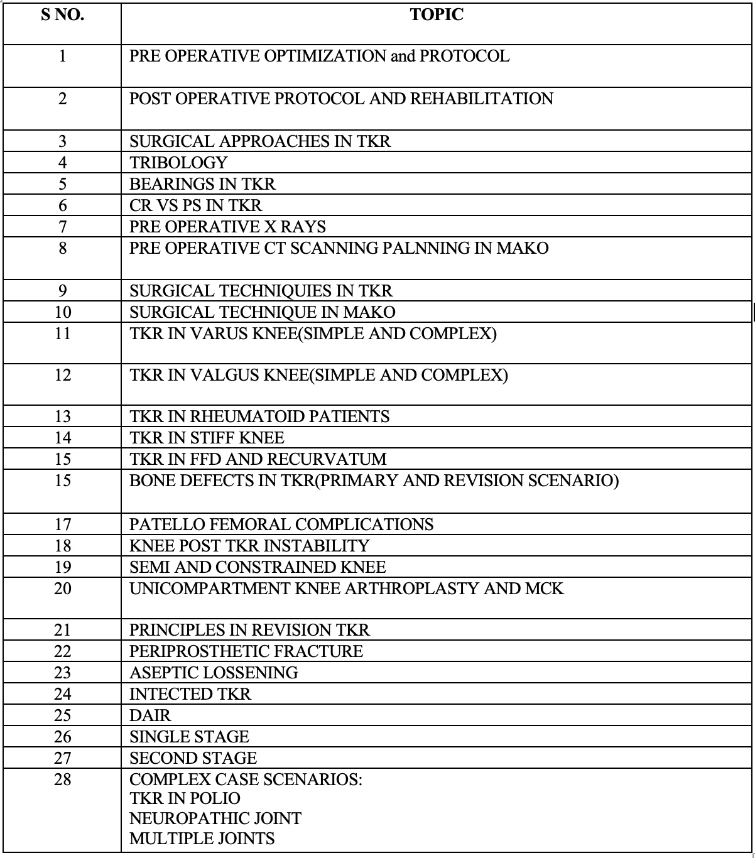

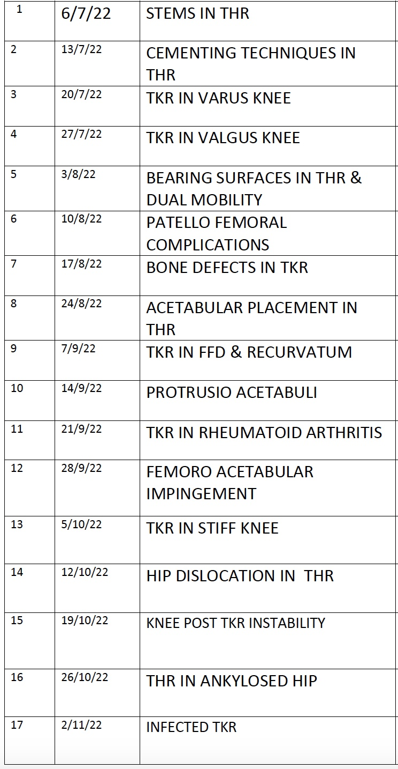
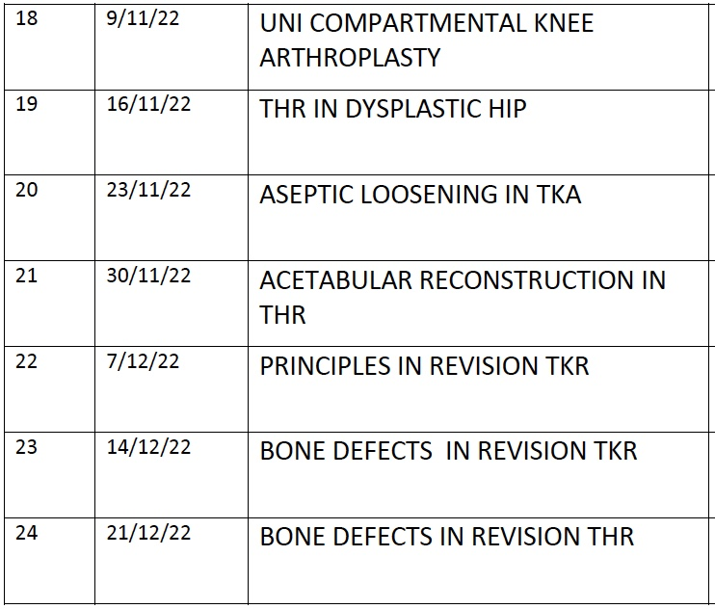

Research Commitments

All fellows are required to take up a minimum of one research topics to complete during their fellowship program. They are encouraged to learn and implement the basics of data collection, analysis and paper writing techniques. The research project should be finished during the course of the fellowship and data/paper draft should be submitted to the mentor prior to certification.

INDUSTRY INVOLVEMENT
- The philosophy, structure and control of the fellowship should be that of the supervisor without influence from the sponsoring party.
- The successful applicant should be chosen exclusively by the supervisor(s) of the Fellowship.
- The presence and extent of any sponsorship should be declared and transparent.
- There is to be no obligatory relationship link between the level or presence of funding and the use of any industry product or service.
- No Fellowship should bear an industry sponsor’s name
- Apart from appropriate acknowledgement, there is to be no prominent advertising of the industry’s involvement of the Fellowship on ISHKS material e.g website, brochures etc.

REPORTING PROCEDURES
- At the end of the Fellowship period, the Fellow and the Fellowship Supervisor must submit detailed reports on the prescribed forms to the ISHKS Fellowships Manager. The report forms are available at ISHKS website. The reports must be submitted to his Fellowships Manager, who will forward them to the Fellowships Committee for consideration.
- Upon receipt of the reports, ISHKS will issue a Fellowship certificate to the Fellow.
- Ongoing accreditation of the Fellowship will be conditional on the timely receipt of these reports.
- It is understood that Fellowship positions may remain vacant on some occasions. If however, the Fellowship position remains vacant for more than 18 months, ongoing approval shall not be granted unless there are extenuating circumstances.

REVIEW PROCEDURES
- The Fellowships Committee will review the National Fellowship Programme in all aspects at three (3) yearly intervals, or as required.
- The review of Fellowships will be conducted via the review of exit reports.
- Any Fellowship found not to meet the Guidelines as set down by ISHKS during the review process may be disaccredited if recommendations made to enable the Fellowship to be retained cannot be met.

